Coincident Planes

Definition
# Source: AI Source: Provided by: [Data Path: Persons Table -> ID Column: 1, Name_En Column: Motasem Essam] -> From: [ChatGPT] on [7/25/2026]
Coincident planes are two plane equations that represent exactly the same plane in three-dimensional space. They occupy the same position and share every point.
Unlike parallel planes, which are separated by a positive distance when distinct, coincident planes overlap completely. Unlike intersecting planes, they do not share just one line; every point on one plane also belongs to the other.
For example, the equations
$$P_{1}:x+y+z=6$$
$$P_{2}:2x+2y+2z=12$$
represent the same plane because the second equation is obtained by multiplying the first equation by $2$.
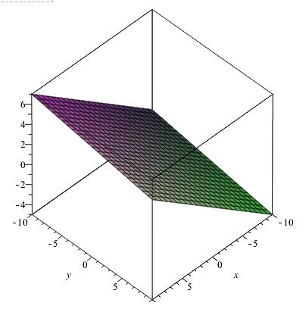

Simple Definition
# Source: AI Source: Provided by: [Data Path: Persons Table -> ID Column: 1, Name_En Column: Motasem Essam] -> From: [ChatGPT] on [7/25/2026]
Two planes are coincident when they are actually the same plane, even if their equations look different.
Examples include:
- Two equations that describe the same flat surface.
- Two identical mathematical representations of a plane using different coefficient scales.
- The equations $x+y=3$ and $2x+2y=6$, which represent the same plane in three-dimensional space because $z$ is unrestricted.

Key Characteristics
# Source: AI Source: Provided by: [Data Path: Persons Table -> ID Column: 1, Name_En Column: Motasem Essam] -> From: [ChatGPT] on [7/25/2026]
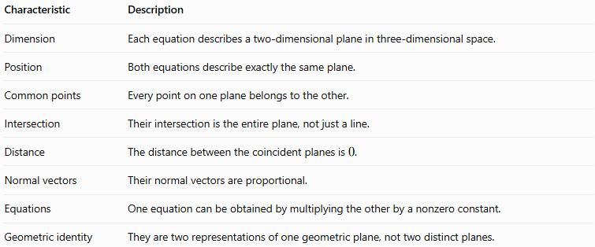
Characteristic | Description
Dimension | Each equation describes a two-dimensional plane in three-dimensional space.
Position | Both equations describe exactly the same plane.
Common points | Every point on one plane belongs to the other.
Intersection | Their intersection is the entire plane, not just a line.
Distance | The distance between the coincident planes is $0$.
Normal vectors | Their normal vectors are proportional.
Equations | One equation can be obtained by multiplying the other by a nonzero constant.
Geometric identity | They are two representations of one geometric plane, not two distinct planes.

Geometric Representation
# Source: AI Source: Provided by: [Data Path: Persons Table -> ID Column: 1, Name_En Column: Motasem Essam] -> From: [ChatGPT] on [7/25/2026]
Coincident planes occupy precisely the same location. In a diagram, they overlap completely, so drawing both separately would show only one visible plane.
The outlines overlap completely because the planes coincide.

Mathematical Representation

General equations of two planes
# Source: AI Source: Provided by: [Data Path: Persons Table -> ID Column: 1, Name_En Column: Motasem Essam] -> From: [ChatGPT] on [7/25/2026]
Consider two plane equations:
$$P_{1}:A_{1}x+B_{1}y+C_{1}z+D_{1}=0$$
$$P_{2}:A_{2}x+B_{2}y+C_{2}z+D_{2}=0$$
The planes are coincident if there exists a nonzero constant $k$ such that
$$\boxed{\begin{aligned}A_{2}&=kA_{1} \\ B_{2}&=kB_{1} \\ C_{2}&=kC_{1} \\ D_{2}&=kD_{1}\end{aligned}}$$
In other words, all four coefficients must have the same proportional relationship.
The first three coefficients determine the normal-vector direction. The constant term must follow the same proportionality for the equations to describe the same plane.

Example of coincident planes
# Source: AI Source: Provided by: [Data Path: Persons Table -> ID Column: 1, Name_En Column: Motasem Essam] -> From: [ChatGPT] on [7/25/2026]
Consider
$$P_{1}:2x+3y-z+5=0$$
$$P_{2}:6x+9y-3z+15=0$$
Multiplying the first equation by $3$ gives
$$6x+9y-3z+15=0$$
This is exactly the second equation. Therefore,
$$\boxed{P_{1}=P_{2}}$$
The planes are coincident.

Relationship with normal vectors
# Source: AI Source: Provided by: [Data Path: Persons Table -> ID Column: 1, Name_En Column: Motasem Essam] -> From: [ChatGPT] on [7/25/2026]
The normal vectors of the two planes are
$$n_{1}=\left(A_{1},B_{1},C_{1}\right)$$
$$n_{2}=\left(A_{2},B_{2},C_{2}\right)$$
For coincident planes,
$$n_{2}=kn_{1}$$
However, proportional normal vectors alone are not sufficient to establish coincidence. The planes could instead be distinct parallel planes. The constant terms must also satisfy the same proportionality.

Worked Examples
# Source: AI Source: Provided by: [Data Path: Persons Table -> ID Column: 1, Name_En Column: Motasem Essam] -> From: [ChatGPT] on [7/25/2026]
Example 1: Determine whether two planes are coincident
Determine the relationship between
$$P_{1}:x+2y+3z-8=0$$
$$P_{2}:4x+8y+12z-32=0$$
Step 1: Compare the coefficients.
The second equation's coefficients are four times those of the first:
$$4=4\left(1\right), 8=4\left(2\right), 12=4\left(3\right)$$
The constant term also follows this relationship:
$$-32=4\left(-8\right)$$
Step 2: Compare the equations.
Multiplying the first equation by $4$ produces the second equation exactly.
Conclusion: The planes are coincident.
Example 2: Distinguish coincident planes from parallel planes
Consider
$$P_{1}:2x+3y+z-4=0$$
$$P_{2}:4x+6y+2z+10=0$$
Step 1: Compare the normal vectors.
$$n_{1}=\left(2,3,1\right)$$
$$n_{2}=\left(4,6,2\right)=2n_{1}$$
The normal vectors are proportional, so the planes are parallel or coincident.
Step 2: Check the constant terms.
Multiplying the first equation by $2$ gives
$$4x+6y+2z-8=0$$
But the second equation has constant term $+10$, not $-8$.
Conclusion: The planes are distinct and parallel, not coincident.
Example 3: Identifying coincident planes in coordinate geometry
Consider
$$P_{1}:z=5$$
$$P_{2}:3z-15=0$$
Rearranging the second equation gives
$$3z=15⟹z=5$$
Both equations describe every point whose $z$-coordinate is $5$, regardless of $x$ and $y$.
Therefore,
$$\boxed{P_{1}=P_{2}}$$
The planes are coincident.

Comparison with Related Concepts
# Source: AI Source: Provided by: [Data Path: Persons Table -> ID Column: 1, Name_En Column: Motasem Essam] -> From: [ChatGPT] on [7/25/2026]
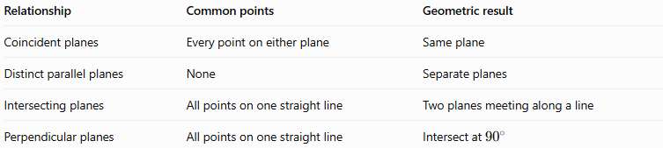
Relationship | Common points | Geometric result
Coincident planes | Every point on either plane | Same plane
Distinct parallel planes | None | Separate planes
Intersecting planes | All points on one straight line | Two planes meeting along a line
Perpendicular planes | All points on one straight line | Intersect at ${90}^{∘}$
The key distinction is the number and arrangement of common points. Coincident planes share an entire plane, whereas distinct intersecting planes share only a line.

Applications
# Source: AI Source: Provided by: [Data Path: Persons Table -> ID Column: 1, Name_En Column: Motasem Essam] -> From: [ChatGPT] on [7/25/2026]

Coordinate geometry
Different algebraic equations can represent the same geometric plane. Recognizing coincidence simplifies equation systems.
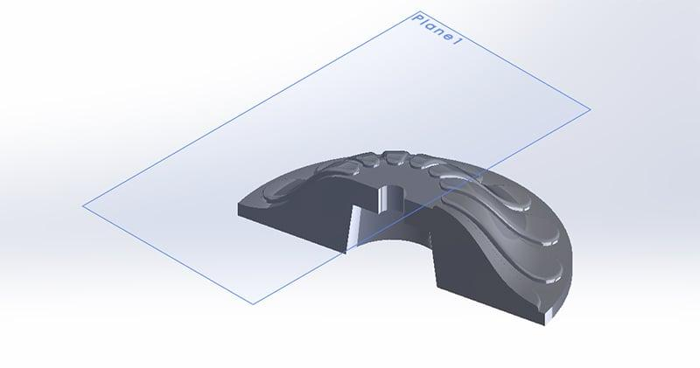
Computer-aided design
Identifying duplicate geometric surfaces helps avoid redundant geometry in three-dimensional models.
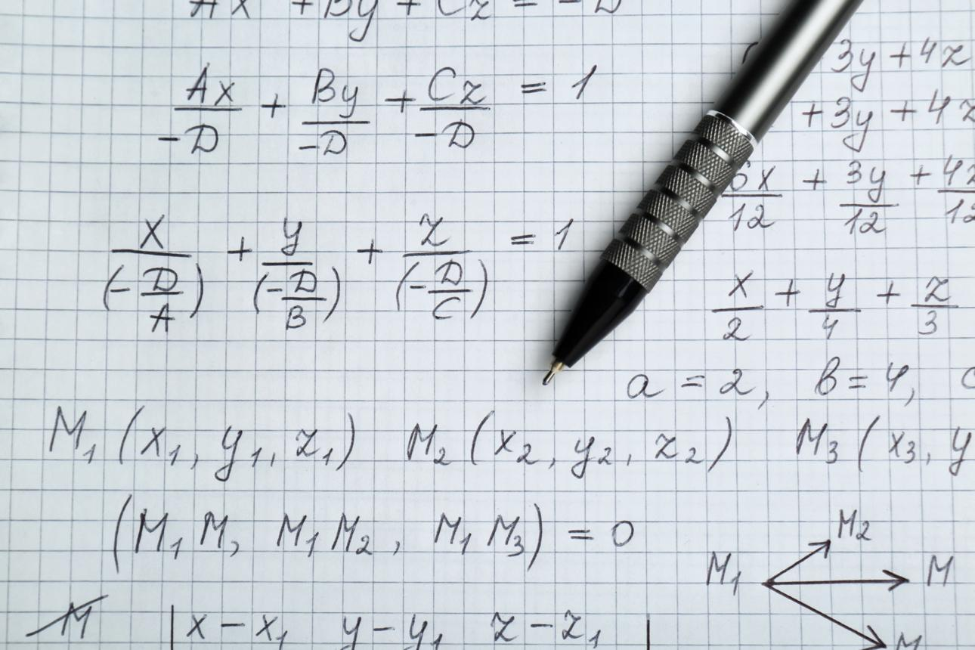
Linear algebra
Proportional equations describe identical geometric constraints, which is useful when solving systems of equations.

Key Points
# Source: AI Source: Provided by: [Data Path: Persons Table -> ID Column: 1, Name_En Column: Motasem Essam] -> From: [ChatGPT] on [7/25/2026]
- Coincident planes are two equations representing exactly the same plane.
- Every point on one plane belongs to the other.
- Their geometric separation is zero.
- Their normal vectors are proportional.
- All four coefficients, including the constant term, must share the same proportionality factor.
- Proportional normal vectors alone indicate parallel or coincident planes, so the constant term must also be checked.
- Coincident planes share an entire plane, unlike intersecting planes, which share a line.

Conclusion
# Source: AI Source: Provided by: [Data Path: Persons Table -> ID Column: 1, Name_En Column: Motasem Essam] -> From: [ChatGPT] on [7/25/2026]
Coincident planes represent the same flat surface in three-dimensional space, even when their equations look different. By comparing all equation coefficients, we can determine whether two planes coincide or are merely parallel. This distinction is fundamental in solid geometry, coordinate geometry, and three-dimensional modeling.

